Student´s MMD Semestral Report

Instructions: After each semester, each student participating in MMD programme is required to fill in all required information (texts in blue font) and to attach relevant annexes (Annex 1 is obligatory). Final document (in PDF) should be submitted to “Homeworks vault” of XD007 programme in IS at the end of each semester.
- Student´s name: …name…

- Student´s ID number: …UČO…

- Faculty: …SCI / MED / SPORT / PHARM…

- Doctoral study programme: …Name of the doctoral programme…

- Semester: …. spring or autumn + academic year…

- Student´s progress in the semester
(Brief self-evaluation; list of main activities and achievements, participation at conferences, published papers; recommended length is one paragraph, 7-10 lines/bullet points)

…. student´s text here…

- Placement abroad during this semester. Yes ☐ - No ☐
If yes, provide detailed information according to requirements in the main MMD Document.
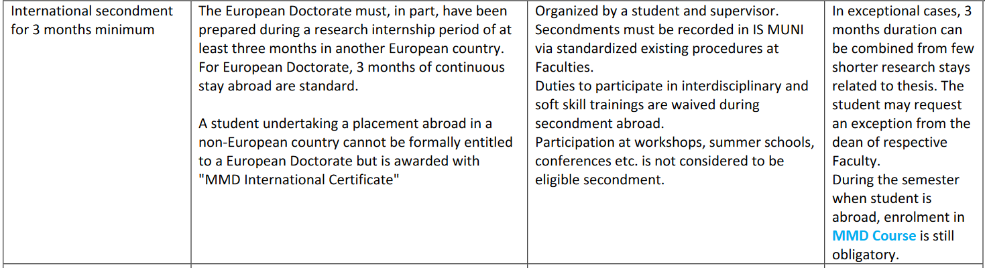

Hosting institution: …. Institution, address, country…

Duration from – to: …. Starting and finishing dates…

Confirm/describe how placement abroad is recorded in IS MUNI: … student´s text here…

- MMD activities and requirements
Describe MMD-related activities according to requirements in the main MMD Document.
Provide certificates or confirmation letters for externally offered activities (attach as Annexes)

  - Interdisciplinary trainings.
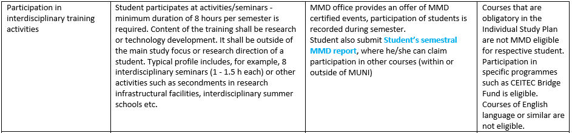
…. student´s text here (Fill in the name of the course, incl. information about the number of hours spent
on the course/webinar) …

  - Transferable and soft skills training activities.
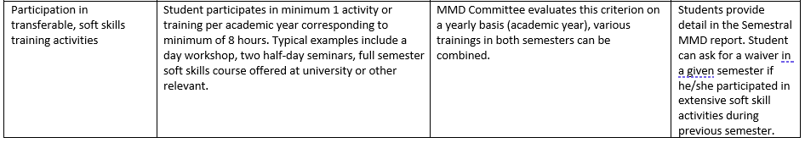

…. student´s text here…

  - Minimum monthly income during the semester
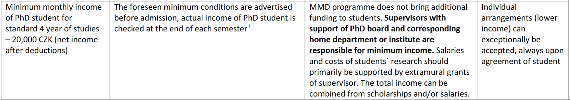

Student´s confirmation statement: By submitting this Semestral report, I confirm that during the semester concerned, I have received financial support for my living costs corresponding to minimum net income of 20 000 CZK as required by the MMD programme. (Salary + stipend)

Annexes

ANNEX 1 (OBLIGATORY)

- E-mail from your supervisor.
Attach an email that should contain essential information according to the Email template, which is available here.

Additional ANNEXES (optional) can be attached:

- Proofs of participation in MMD-relevant activities (interdisciplinary training, soft skill courses, on-line courses etc.) - certificates or letters of confirmation

- Other relevant documents or proofs

Texts prepared by a student for formal reporting of the study progress in IS MUNI (Semestrální náplň / Term content) can be used – copy/pasted – here in the MMD Semestral Report.
Student can skip paragraph 8 when on a placement abroad (MMD duties are waived during the stay abroad)

